**PHOTOGRAPHY ASSIGNMENT**

**BY MOHD ABDUL SAMI**

**2024090201**

**SHUTTER SPEED:**

**CORRECT EXPOSED:-**

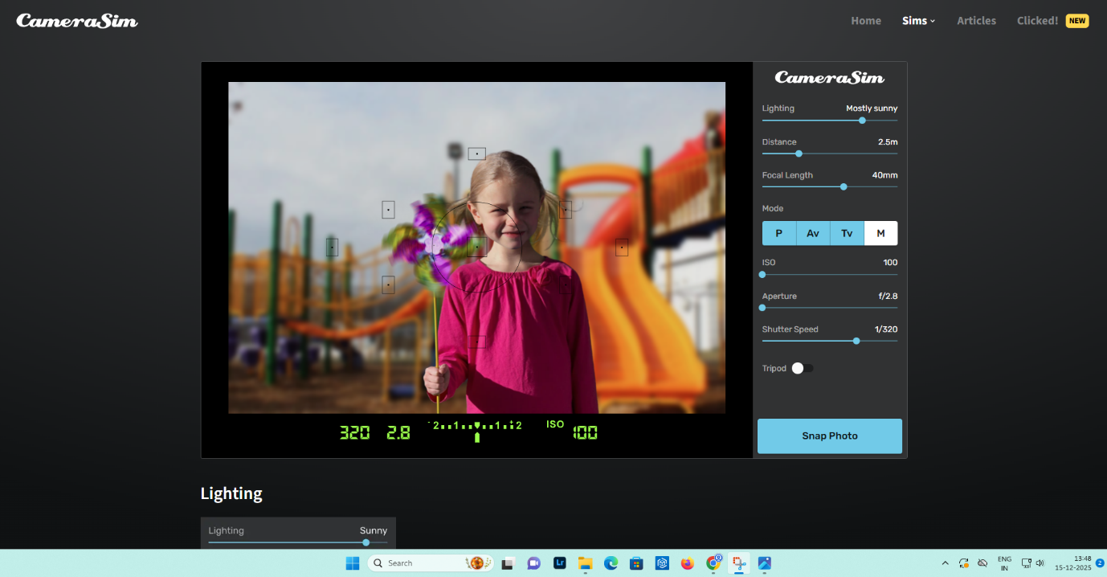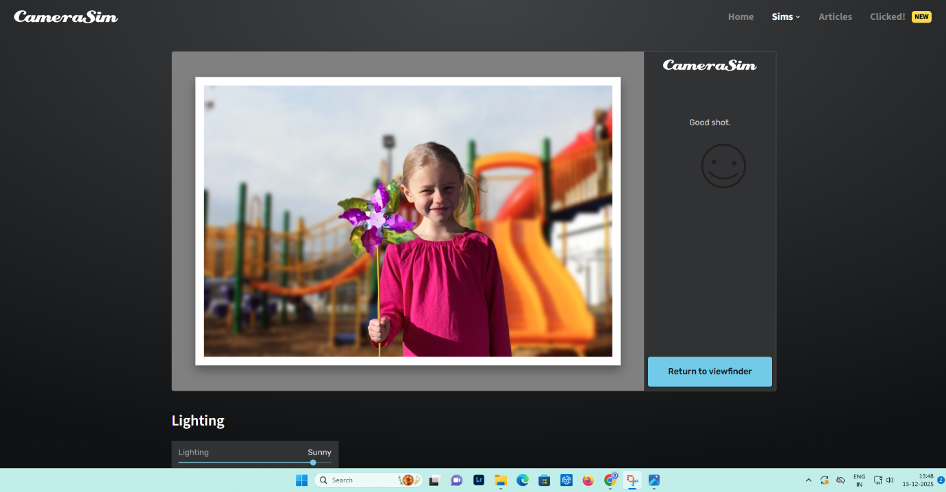

**UNDEREXPOSED:-**

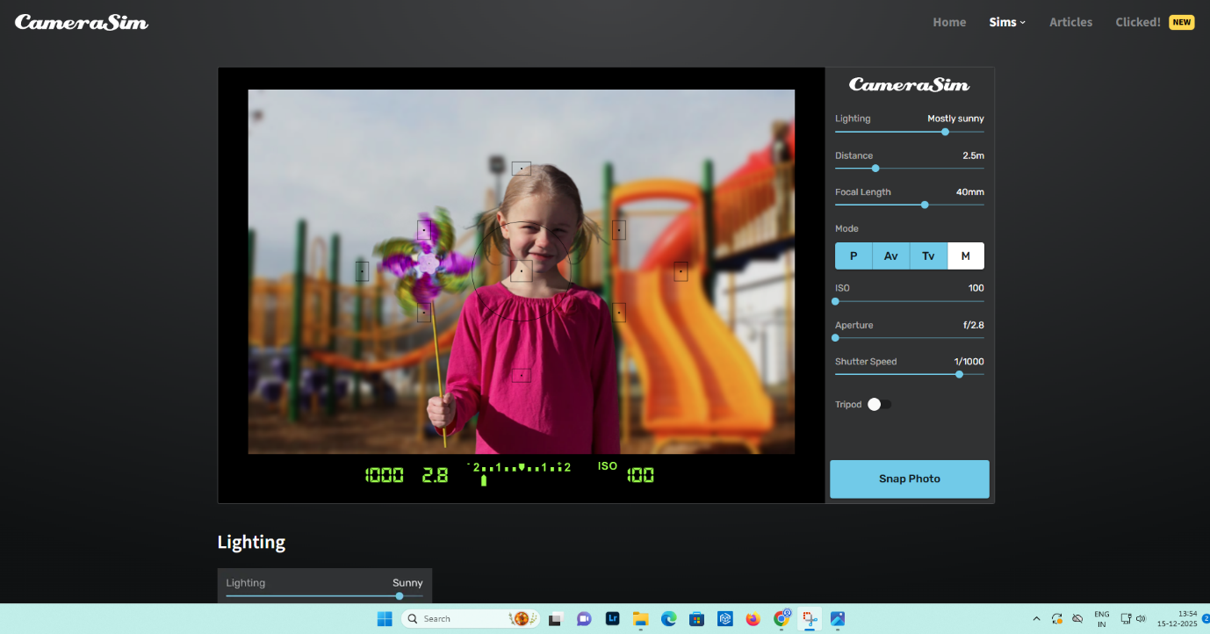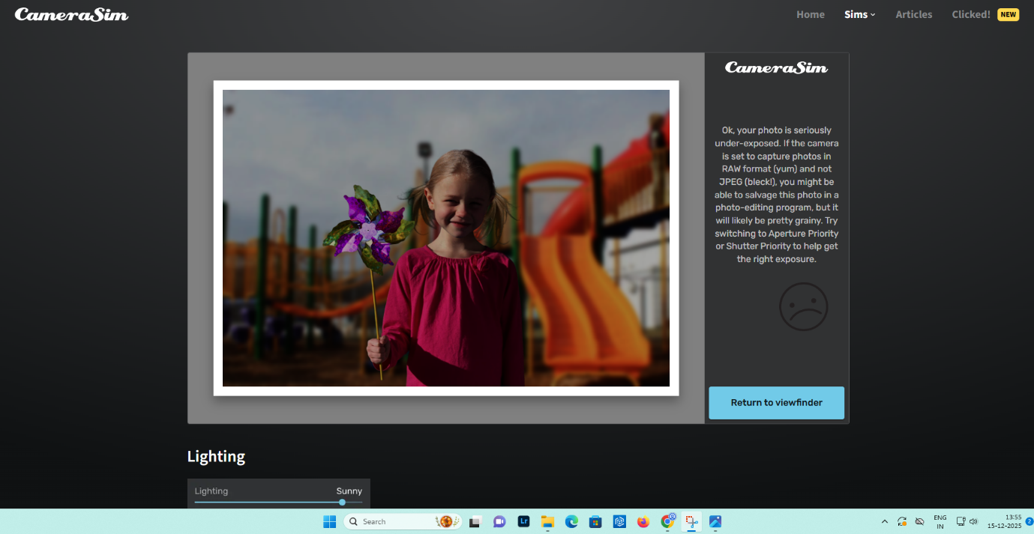

**OVEREXPOSED:-**

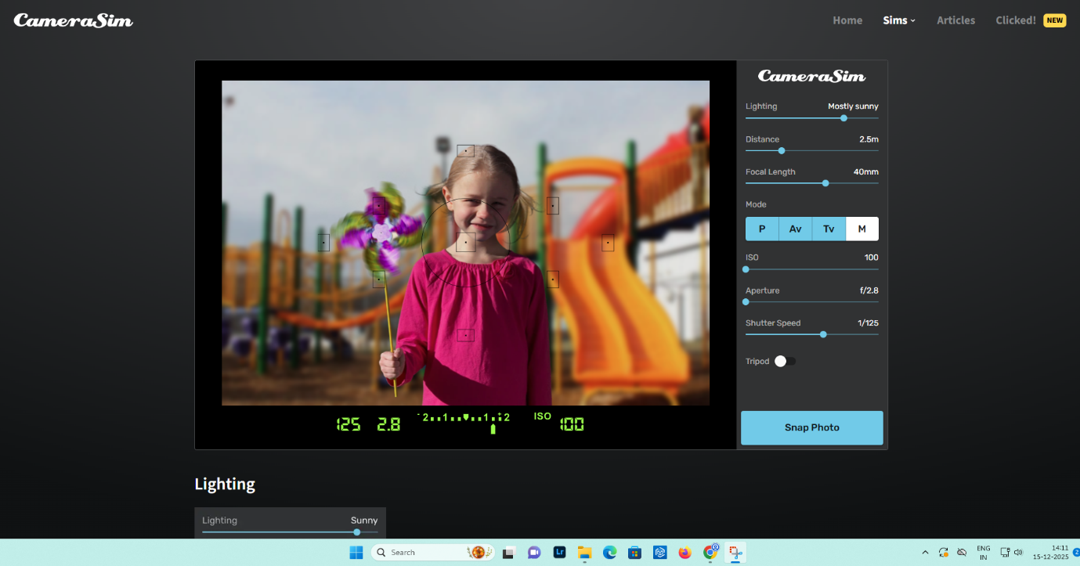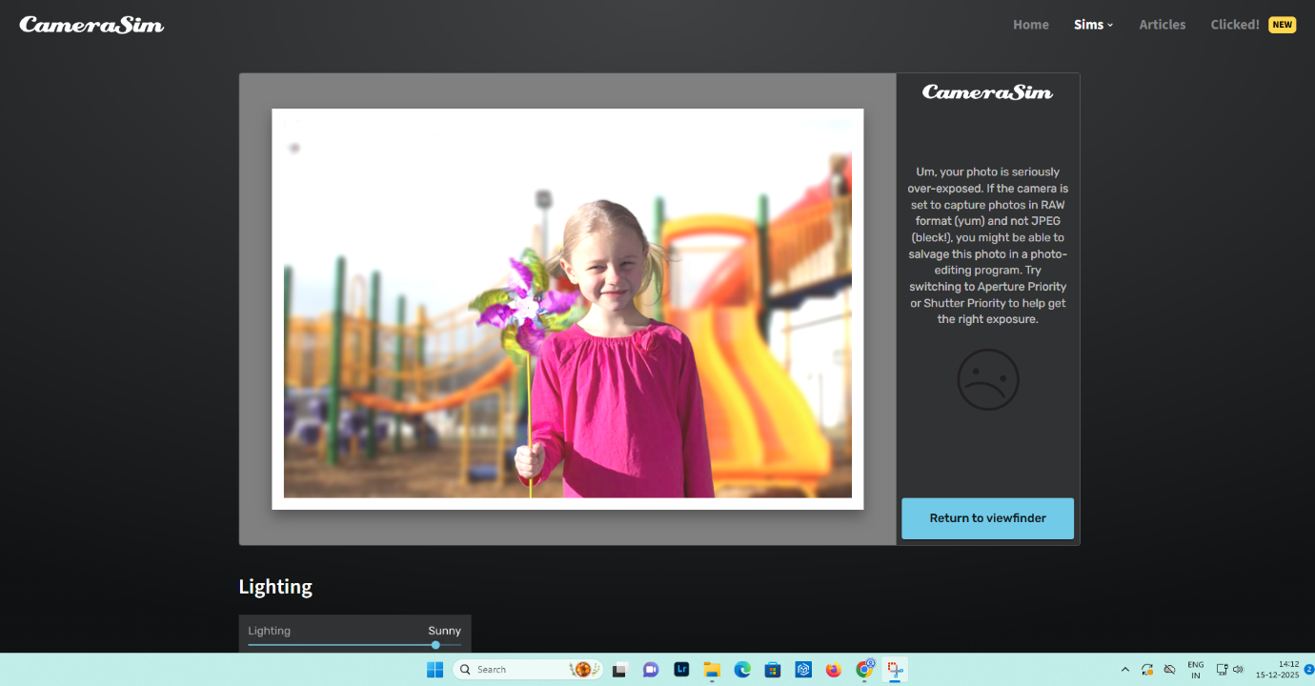

**APPERATURE:-**

**CORRECT EXPOSED:-**

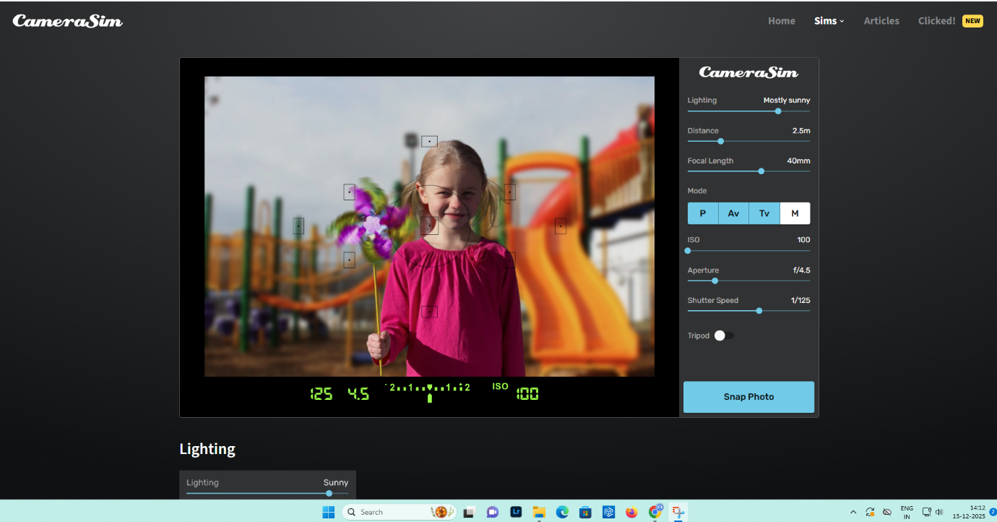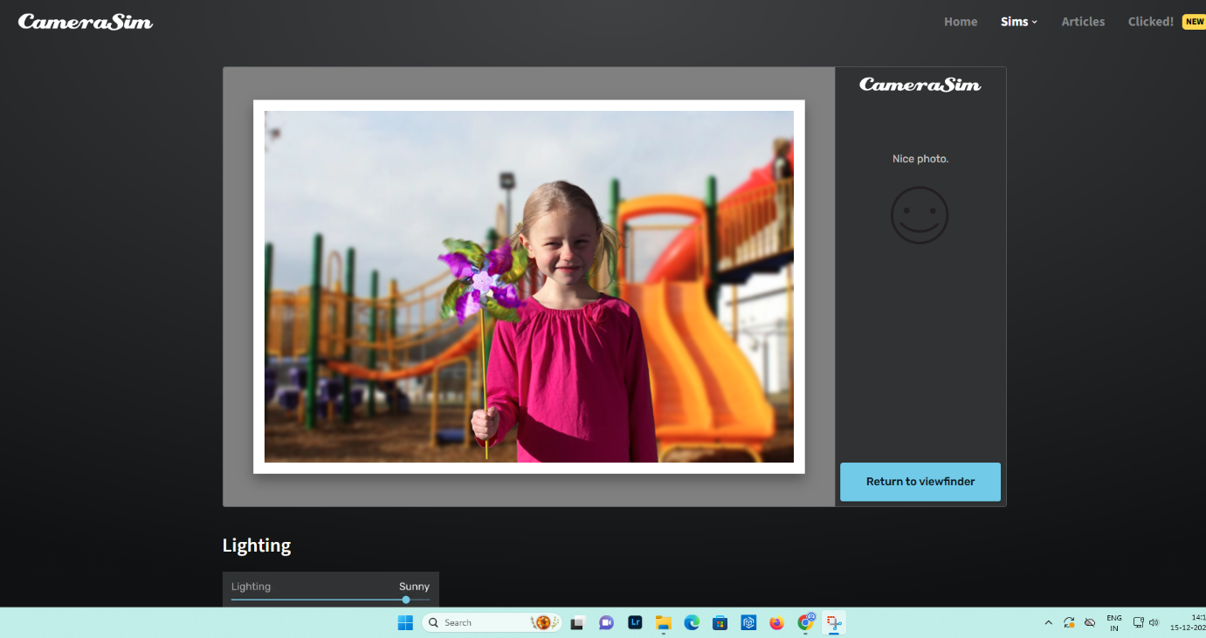

**UNDEREXPOSED:-**

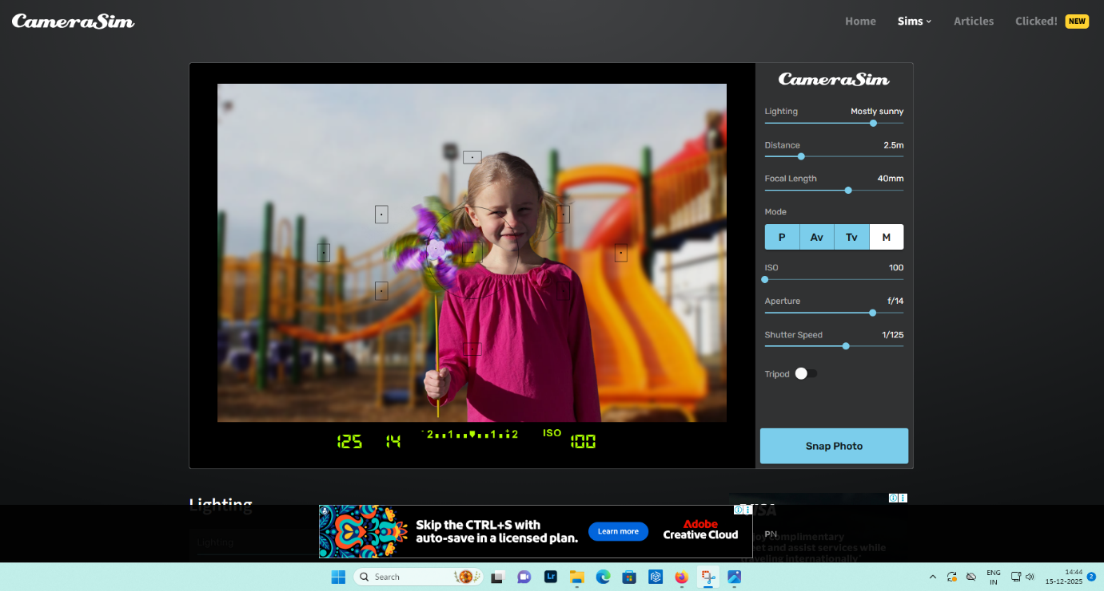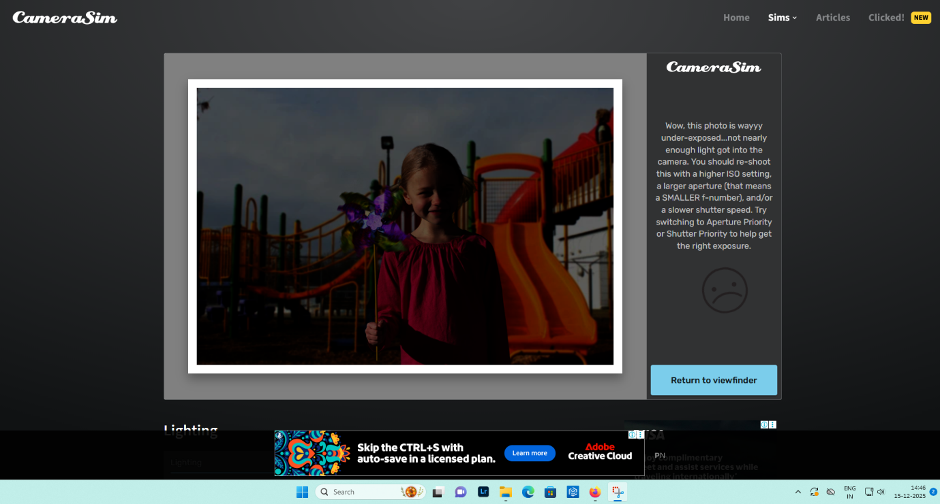

**OVEREXPOSED:-**

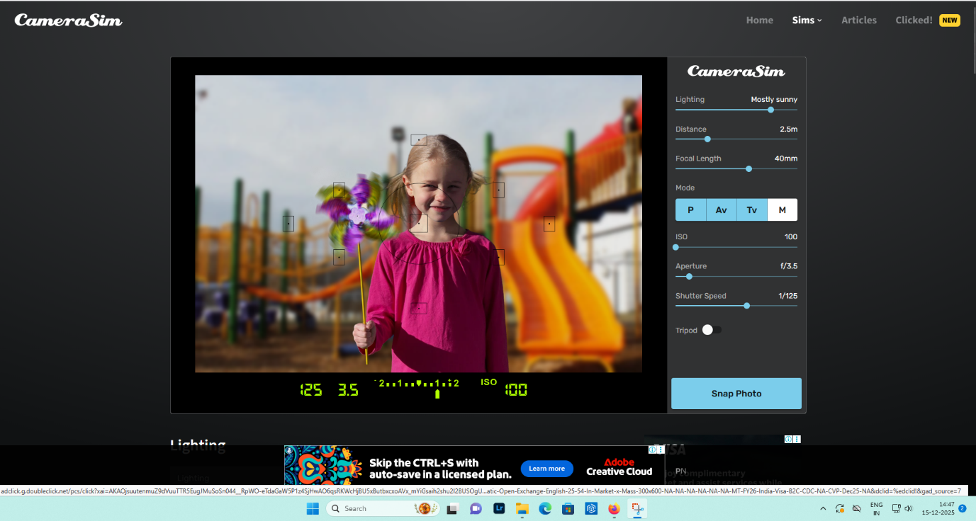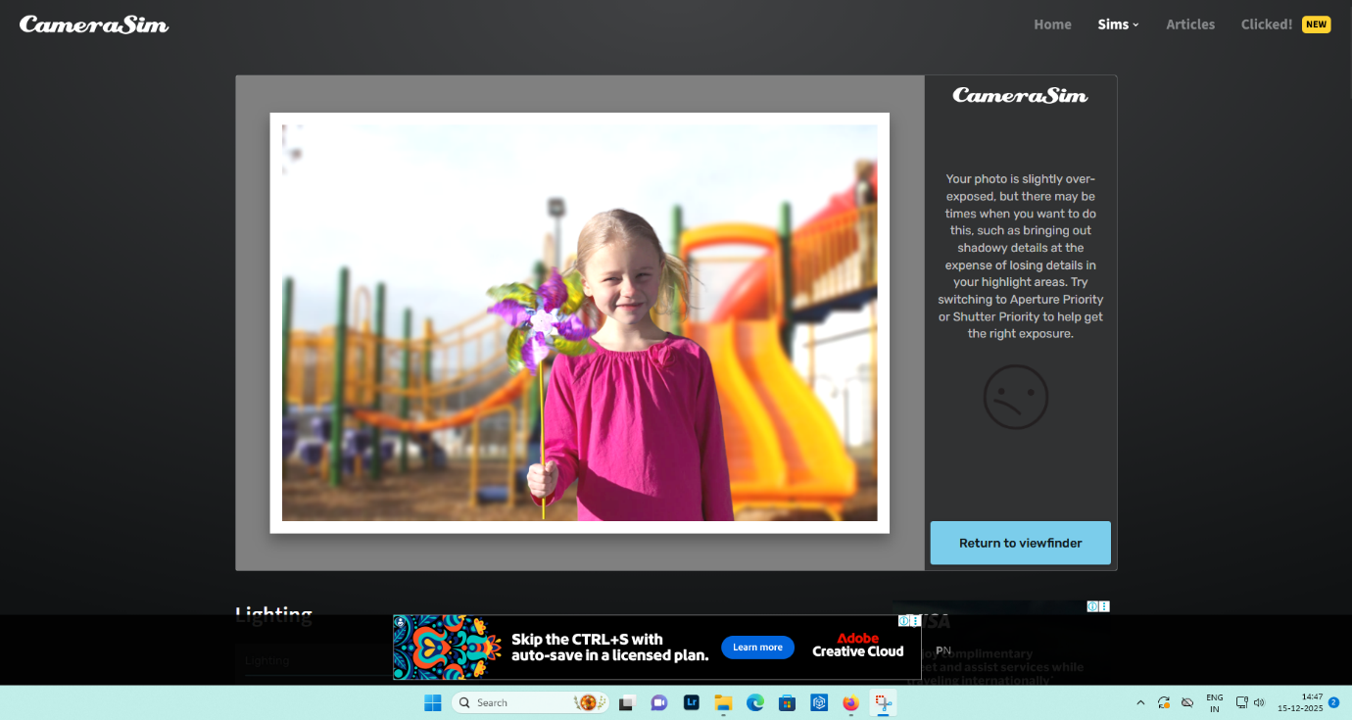

**ISO:-**

**UNDEREXPOSED:-**



**CORRECT EXPOSED:-**



**OVEREXPOSED:-**

